Final Reading Report with Progress Monitoring

Jennifer Aussicker
School Psychology Program, Rider University
EDPS 515: Curriculum-Based Assessment
Dr. Karen Gischlar

1 April 2024
Student: Sada McMurphy
Grade: 3rd Grade
Age: 8 years, 2 months
Teacher: Mr. Preacher
School: New Dawn Elementary School
Curriculum Based Measurement

Reason for Referral
Sada has been referred for evaluation as Mr. Preacher has noticed her reading “below” 3rd grade level. Further, she has difficulty decoding unfamiliar words, which impacts fluency and comprehension.

Background Information
Sada is a third grade student in a general education classroom setting. Sada lives at home with her biological parents and younger twin brothers, Peter and Parker, who are in kindergarten. Her kindergarten, 1st, and 2nd grade report cards reflect average to above average work and good behavior. She has had near perfect attendance since kindergarten and, at least once per school year, has been named a “Good Citizen.” Sada does not have any standardized test scores available, but performed at or above the expected levels in reading and math during previous years. Sada does not receive any accommodations or special services, does not have an IEP or 504 plan, and a recent screening by the school nurse revealed intact hearing and vision.

Assessment Methods
- Teacher Interview (2/2/2024)
  - Mr. Preacher (General Education Teacher)
- Student Interview (2/2/2024)
- Classroom Observation (2/2/2024)
- Curriculum-Based Measures: Oral Reading Fluency

Assessment and Interpretation
Teacher Interview
The New Dawn Elementary School uses the Open Court curriculum from McGraw-Hill. Sada’s teacher, Mr. Preacher utilizes additional pieces including: Foundational Skills and Word Analysis Kits; Lesson, Unit, and Benchmark Assessment books; and Skills Practice book. Reading is taught in Mr. Preacher’s classroom for a 90-minute block each morning: 40 minutes are devoted to full class instruction; 30 minutes are spent in flexible small groups; and, 20 minutes are spent on independent skills practice. Mr. Preacher notes that Sada is often in the skills groups devoted to decoding, word analysis, and comprehension.
Sada struggles with independent work that requires her to practice decoding skills and/or read a passage and answer comprehension questions; typically, she earns grades of 70% to 80%. Mr. Preacher does not consider Sada to be failing, but “behind” other students and he is starting to see an impact in other content areas, including science and social studies. Sada is good at math computation and generally can complete word problems without support. Sada is kind, conscientious, and a hard worker; she does not seem frustrated when asked to read out loud and willingly takes corrections from Mr. Preacher and her peers. Mr. Preacher reports a good relationship with Sada’s parents and sends home practice work that they complete with her.

Student Interview
Sada reported that her favorite school subject is “All of them!! I love Mr. Preacher and my friends!” Sada stated that her best subject is Physical Education, since she plays on two soccer teams, including a recreational team and a traveling team. She is able to be competitive and excel at the game on the teams. She also enjoys science with Mr. Preacher since he does fun things, such as blowing up a volcano they made, playing with magnets, and having a weather station. Sada finds Writing to be the most difficult subject. She explains, “I have really good ideas, but some of the words are hard to spell and I think my handwriting is messy, but I do okay at it, I guess.” For fun, Sada plays soccer, having friends over, having sleepovers and eating pizza with friends. If Sada had three wishes, her wishes would be as follows: (1) to play soccer professionally when she grows up; (2) to have Ella and Maya live at her house because they are her best friends; (3) to have a giant snowstorm so she can make a giant snowman, go sledding, and have a day off.
Classroom Observation
The observation occurred from 10:00 to 10:30 on Tuesday, February 1, 2024; for the first 10 minutes, students were in small skills groups and then transitioned to independent seatwork for the last 20 minutes of the observation period. In total, there were 24 students and 1 teacher present. Desks were pushed together in groups of four to form small cooperative groups. The room was brightly decorated with children’s artwork and multiple academic posters.
During the skills group, Sada and three other students were seated at a table with Mr. Preacher playing a word building game with letter tiles. Sada was observed to struggle most with short vowels and vowel diphthongs when building words to match pictures. Additionally, it was observed that she appeared confident with consonant sounds, including blends, and was correct in 100% of her choices for those letters. Mr. Preacher provided individual attention in helping Sada figure out which vowels to use. She readily accepted his help and seemed to enjoy working with him.
During independent seatwork, students were seated in their cooperative groups and were assigned a reading passage that utilized words from the full group portion of the lesson. They were to read and then answer a series of literal and inferential comprehension questions. As Mr. Preacher circulated, he stopped to help Sada. When she read sentences out loud to him, she stumbled over a few words. Once Sada and Mr. Preacher worked on the missed words, she was able to read fluently and answer the majority of comprehension questions correctly. Sada appeared to be engaged and on-task throughout the observation period.

Curriculum-Based Measures: Oral Reading Fluency
Probe | WCPM | Errors | Accuracy | Percentile
1 | 78 | 7 | 91.76% | 20th
2 | 82 | 9 | 90.11% | 23rd
3 | 71 | 4 | 94.67% | 14th
Median | 78 | 7 | 91.76% | 20th

Sada was administered a survey level assessment (SLA) for reading at the 3rd grade level. The purpose of the SLA was to obtain a representative picture of how many words Sada can read correctly, and how many errors she makes, while reading aloud three 1-minute timed passages. For these three probes, Sada’s intervention and goal setting were based on the median score of 78 words correct and 7 errors. The median score was used for these purposes because it is not impacted as greatly as the use of the mean could be by outlying scores, which can result from unfamiliarity with text vocabulary and/or content. Sada’s score placed her at the 20th %ile, which shows that compared to peers, she scored higher than 20% of them. The 20th %ile places Sada just below the average performance range in 3rd grade level material.

Summary
Overall Student Performance
Overall, assessment methods indicated that Sada is at-risk for not making adequate progress in reading. Her oral reading fluency survey-level assessments indicated that Sada is within the 20th percentile for 3rd grade winter oral reading fluency. Sada’s teacher also stated concerns with Sada’s reading performance and progress with difficulties in decoding, word analysis, and comprehension. Additionally, Mr. Preacher began to notice an impact in other content areas, including science and social studies.

Goals
Sada was referred for reading and comprehension difficulties by her teacher, Mr. Preacher. In previous years, Sada has performed at or above the expected levels in reading and math. This year, however, Mr. Preacher has noticed her reading “below” 3rd grade level. Sada does not have an IEP or a 504 plan. An interview with Mr. Preacher revealed several problem areas for Sada, but also some strengths that Sada possesses within reading as well. In an interview with Sada, she explained that writing is her most difficult subject, since she has great ideas but a hard time spelling and having neat handwriting. In contrast, her two favorite subjects are Physical Education and Science.
Sada’s reading survey level assessment showed that she scored in the 20th percentile. She had a median of 78 words correct per minute and 7 errors, placing her just below the average range of performance for 3rd grade students.
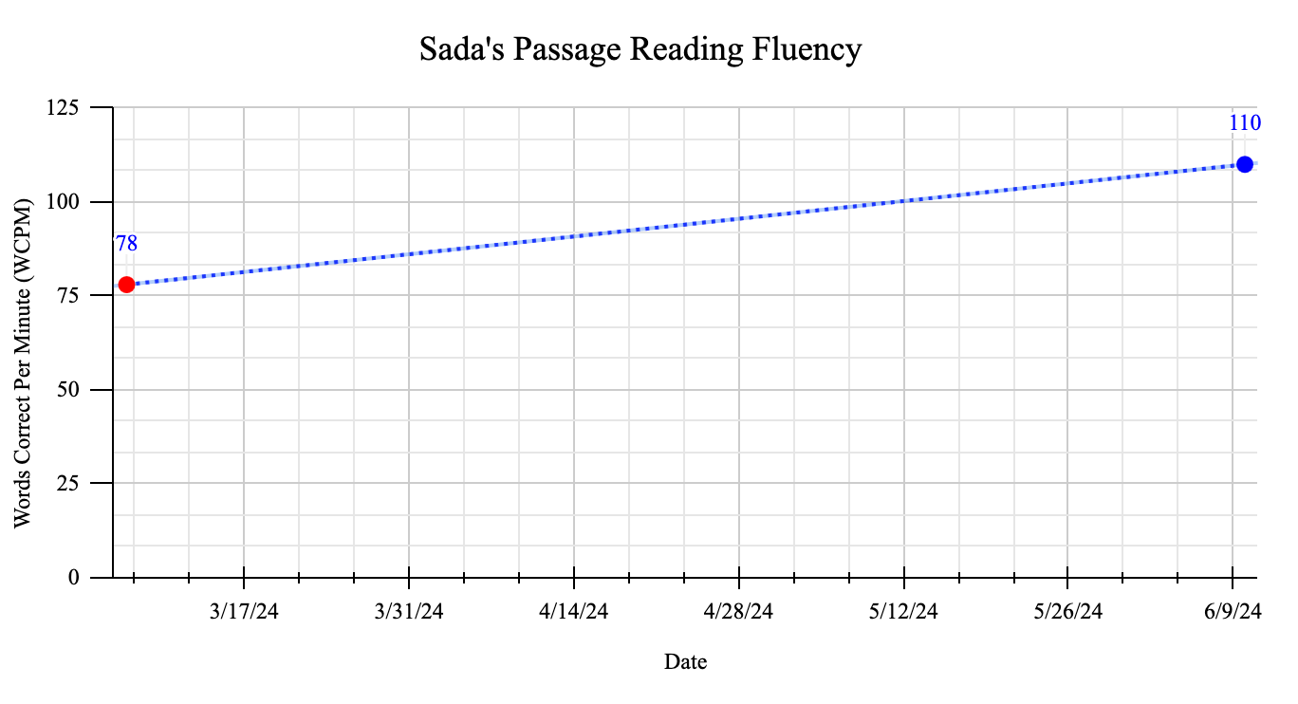

Reading Progress Monitoring
Recommendations
Sada would benefit from additional supports that target fluency, comprehension, and decoding unfamiliar words. Since Sada is currently reading at the 20th percentile with 78 correct words per minute, her goal for the spring benchmark would be 110 correct words per minute. This would place her at the 50th percentile for 3rd grade level material. Starting on February 12th, 2024, Sada will have to increase her performance by 2.1 words each week in order to reach this goal.
In order to help her reading skills, Sada can benefit from additional supports surrounding oral reading in particular. These supports include repeated reading, where students are asked to read aloud short text passages (50-200 words) until they reach a criterion level of success (particular speed and accuracy goals). This would allow Sada to add some comfortable words into her vocabulary, and boost her confidence as a reader. With increased confidence, Sada might feel more inclined to attempt reading new, unfamiliar words. Another reading support that could assist Sada in meeting her goal is choral reading. In choral reading, a group of students reads a text together in unison, with the teacher often leading the way. In this setting, children are better able to make mistakes with less attention to themselves, hear from other students and the teacher how to say unfamiliar words, and practice with less scrutiny. One last strategy that could aid Sada in reaching her goal is her teacher or parent modeling fluent reading, then reread the text on her own. In this case, Sada can hear how the words are meant to be said, then practice on her own to solidify the information further.

Intervention
Sada’s oral reading instruction consisted of:
- Sada participated in repeated reading, where students are asked to read aloud short text passages (50-200 words) until they reach a criterion level of success (particular speed and accuracy goals). (5 minutes)
- Sada took part in choral reading, where a group of students read a text together in unison, with the teacher, Mr. Preacher, leading the way. (10 minutes)
- Mr. Preacher modeled fluent reading, then Sada reread the text on her own. (5 minutes)

Oral Reading Fluency Performance (Baseline, Intervention, Goal)
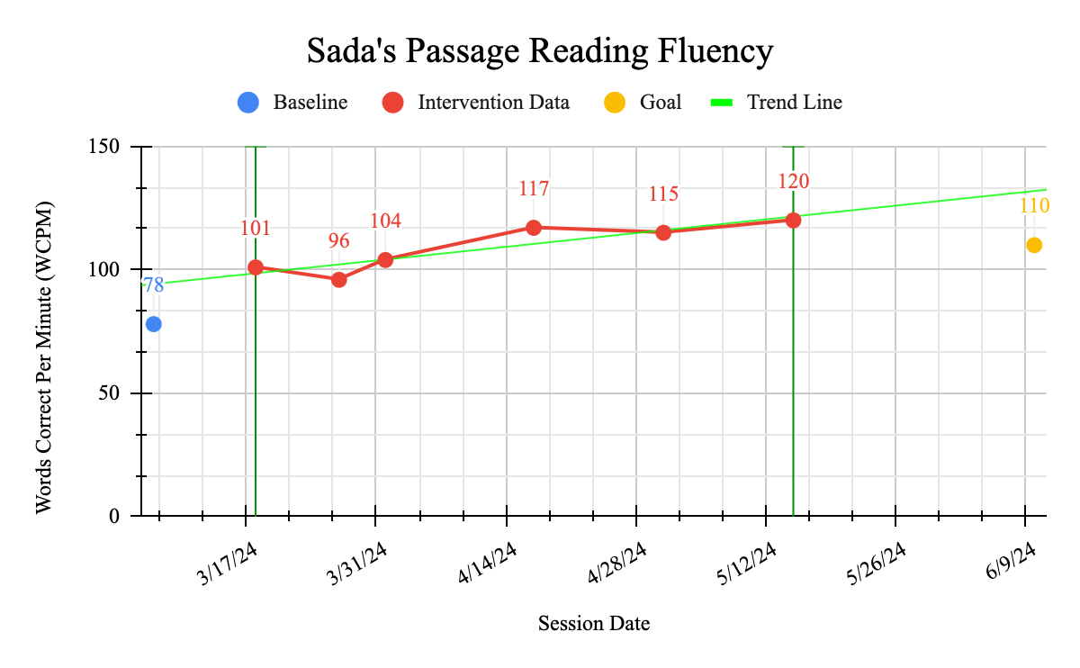

The above graph depicts Sada’s oral reading fluency performance as measured by survey level assessment probes. The graph displays Sada’s oral reading fluency performance at baseline, during intervention, and at set goal. The data points in the intervention phase indicate that Sada’s oral reading fluency is improving, as shown by the ascending trend line, at a steady rate with low variability. The low variability within the intervention phase indicates that Sada’s performance on the oral reading fluency probes is likely representative of her typical performance. The level from the baseline phase to the intervention phase was 19 (120-101). This suggests that the intervention was likely related to Sada’s improvement in oral reading fluency. Sada’s average/mean score for oral reading fluency probes during the intervention phase was 108 words correctly read words per minute. The median score for oral reading fluency performance during the baseline phase was 78 correctly read words per minute, which indicates increased oral reading fluency.

Goal Achievement
The effect size, which takes into account the mean and standard deviation for both the baseline and intervention phases, was 0.89, indicating a large difference between Sada’s performance in each of the phases. The effect size, coupled with the visual analysis of the graph,
suggested that Sada would surpass her oral reading fluency goal of 110 correctly read words per minute by the end of the school year (6/9/2024). This was based on Sada’s ascending trend line during the intervention phase and achievement of at least 2 words gained per week (achieved ROI = 2.8 WCPM). Therefore, it is suggested for the intervention currently in place to be discontinued, however, weekly progress monitoring should continue to occur at the 3rd grade level to ensure adequate progress continues.

Jennifer Aussicker 4/1/2024
School Psychology Student

